

Data Analysis & Business Understanding
AI/ML Internship
Week 1 Task
Title: Exploratory Data Analysis of the Online Retail II Dataset

Submitted By:
Name: Areeba Amjad
Roll No: AIMLB01-4950

Submitted To:
Supervisor: Rayyan Khan
Deadline: 4th July 2026

Objective:
A retail company wants to understand customer purchase behavior before investing in a recommendation system. Acting as a data analyst, you are required to explore the provided dataset, identify patterns and data quality issues, and produce a complete Exploratory Data Analysis (EDA) report that helps the company understand who its customers are, which products sell the most, and which countries generate the most revenue.
Dataset Information:
Dataset Name: Online Retail II
Source: UCI Machine Learning Repository
Description:
The dataset contains transactions from a UK-based online retail company between 2009 and 2011. Each record represents one purchased product in a customer invoice.
Tools Used:
- Python
- Jupyter Notebook
Libraries Used
- Pandas
Used for Data manipulation.
- NumPy
Used for Numerical Operations.
- Matplotlib
Used for creating graphs and charts.
- Seaborn
Used for creating statistical visualizations

Task Implementation:
Task 1: Importing the Libraries
All the necessary libraries are imported once so they can be used later on without importing them again and again.
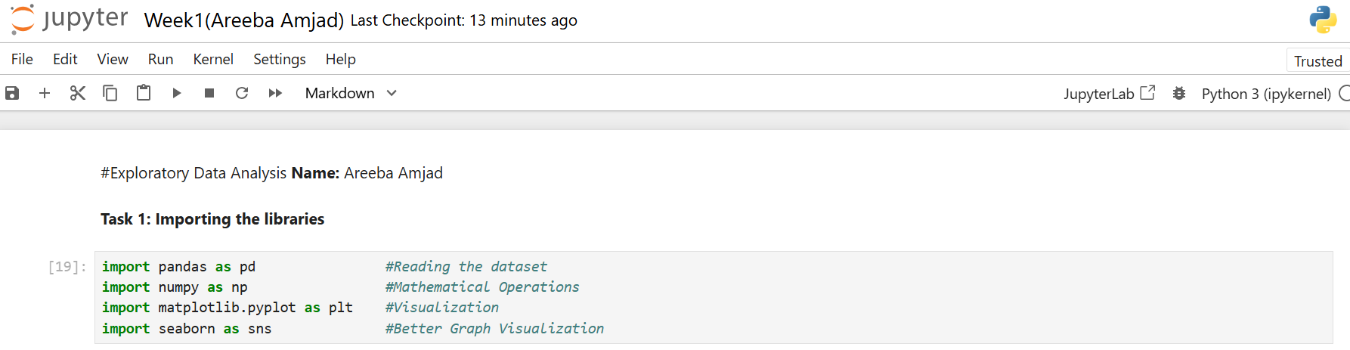
Task 2: Loading the Dataset
Task 3: Displaying Basic Information
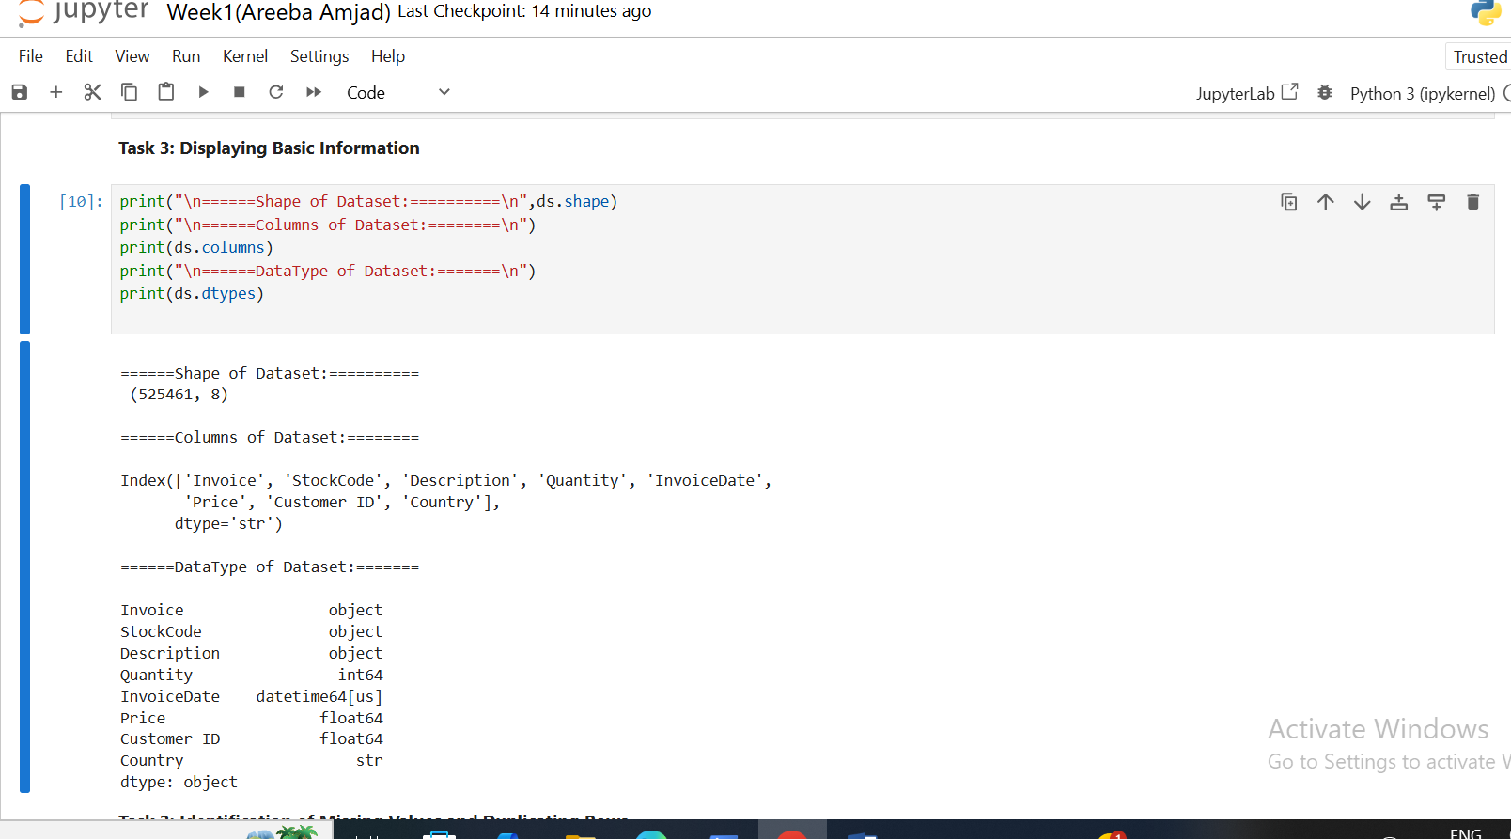
In order to understand the basic structure of the data its shape, columns and data type were examined.

Task 4: Missing Values and Duplicate Rows
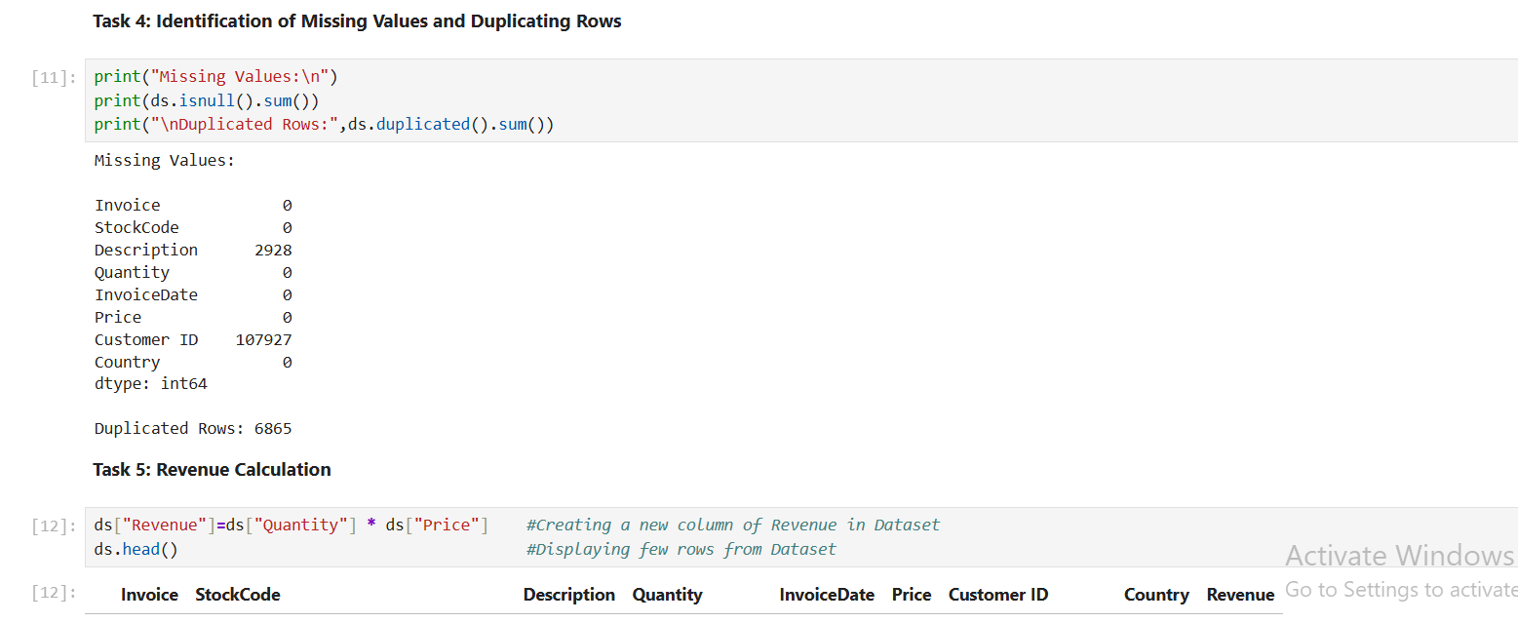
The quality of data was examined by checking the columns having null values and duplicate records. Data was only observed, no deletion of data is performed.
Task 5: Revenue Calculation
A new column was added to the data set with the name revenue which was the product of Quantity and price. Later top 5 rows from the data were displayed.
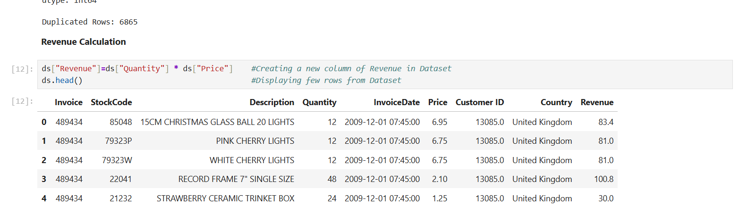
Task 6: Top 10 best-selling products
Using the Description column the products were grouped. The top 10 products were identified based on total Quantity sold and total Revenue generated.
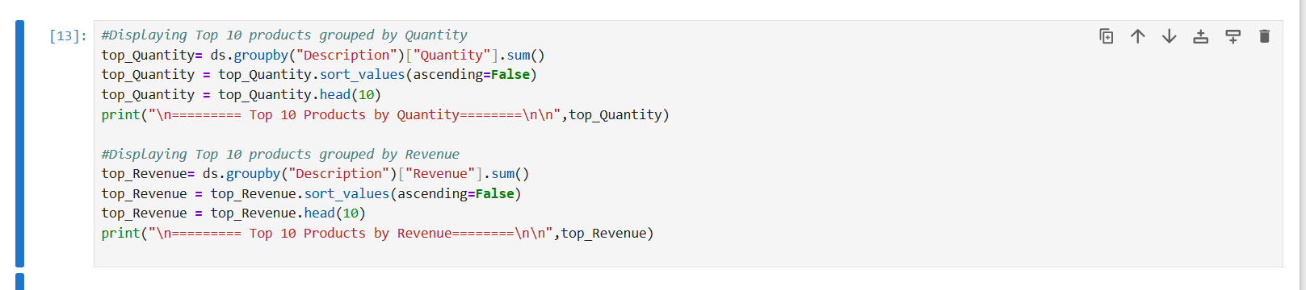
- Quantity:
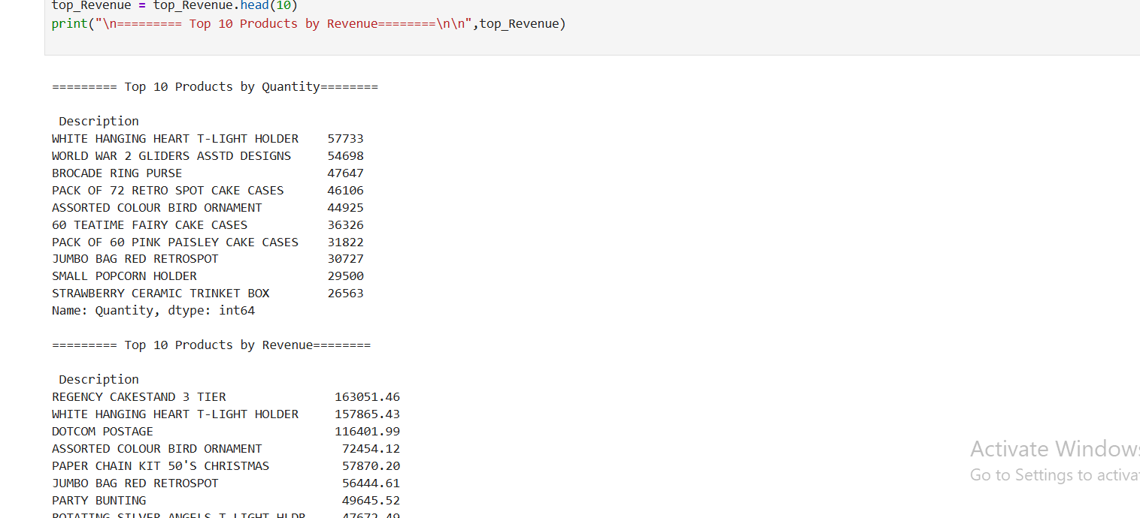

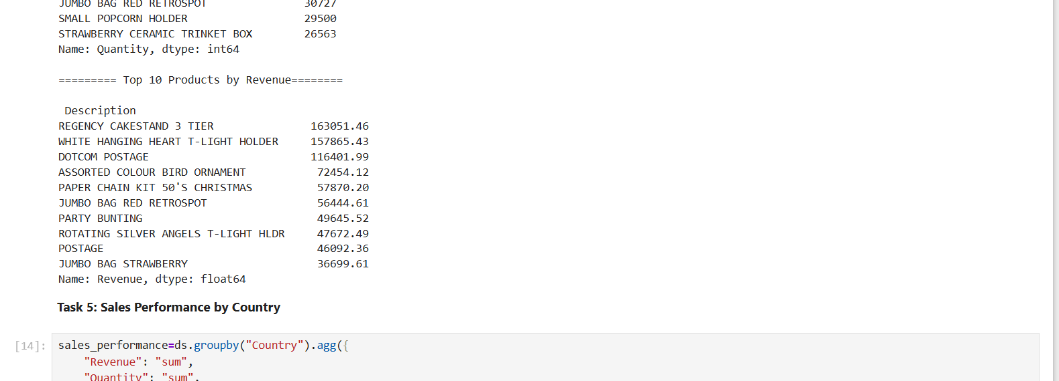
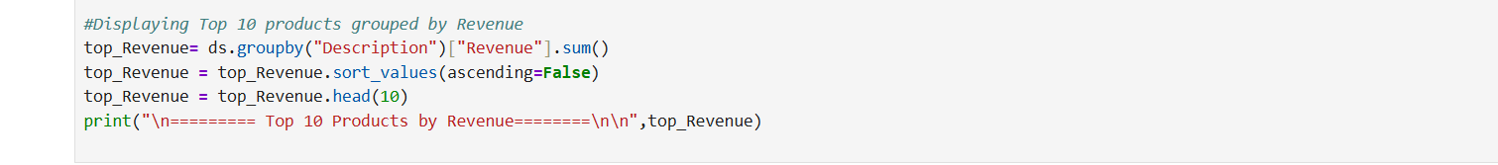
- Revenue:
Task 7: Sales performance analysis by country
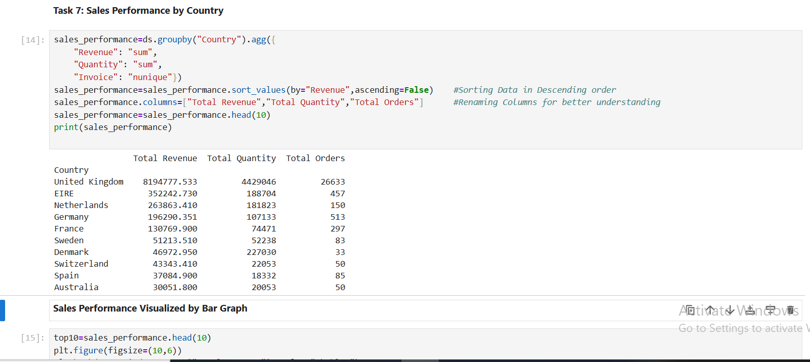
Country-wise analysis was performed in order to calculate the total revenue, total quantity sold ad total number of unique orders placed.
Visualization of sales performance:
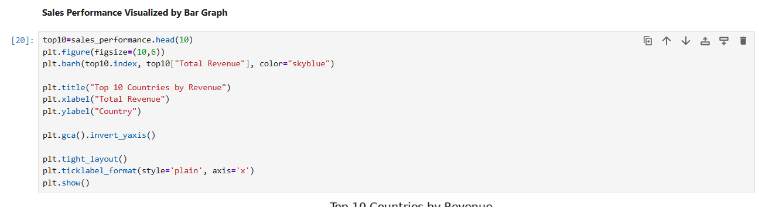
The result was then sorted by total revenue and lastly the performance was visualized using bar chart.
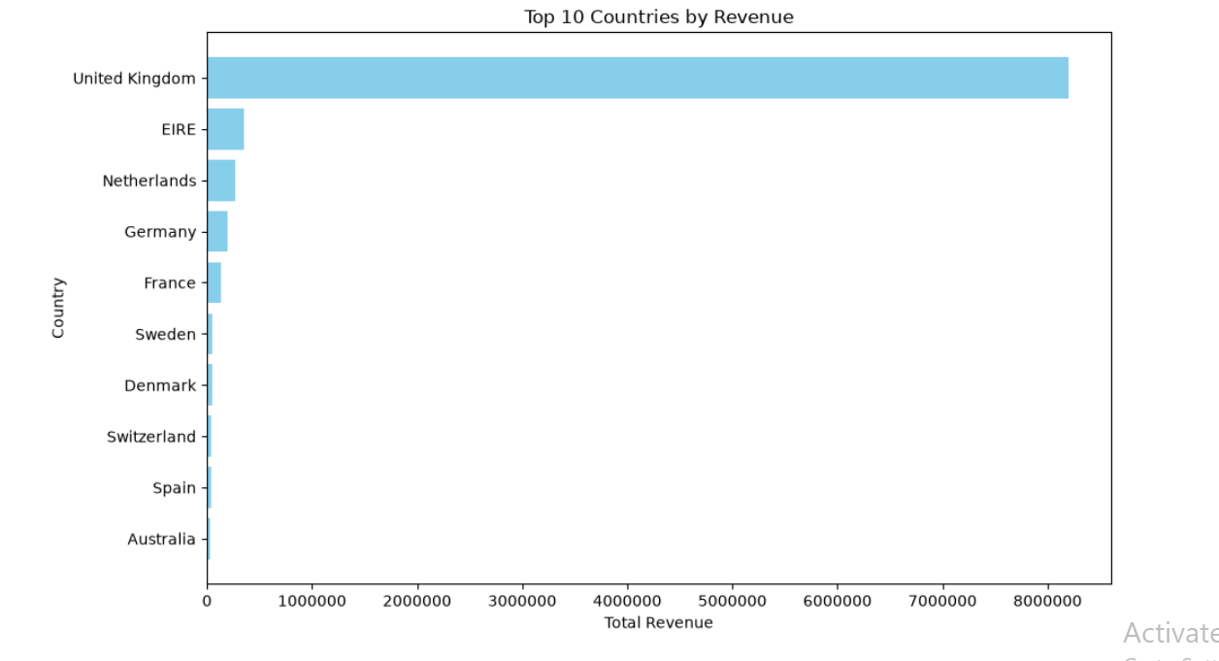
According to the bar graph:
United Kingdom generated the highest revenue among all the other countries, contributing more than 8 million in total revenue. This indicates that the company has highest sales performance in UK as compared to other countries.
Task 8: Monthly Revenue Trend
- The invoice date column was converted into date time format and month was extracted from each column.
- The data was then grouped by month so total revenue generated per month can be calculated.
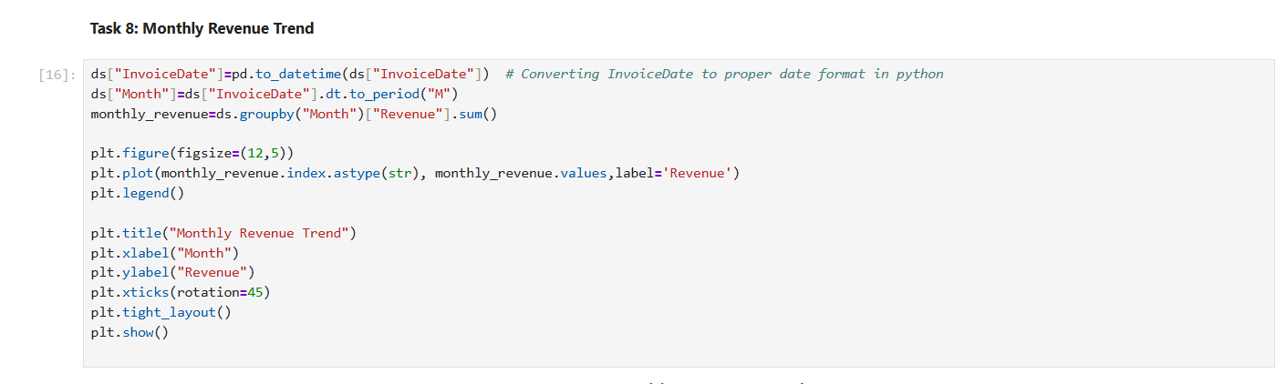
- A line graph was then plotted in order to understand the monthly trend.

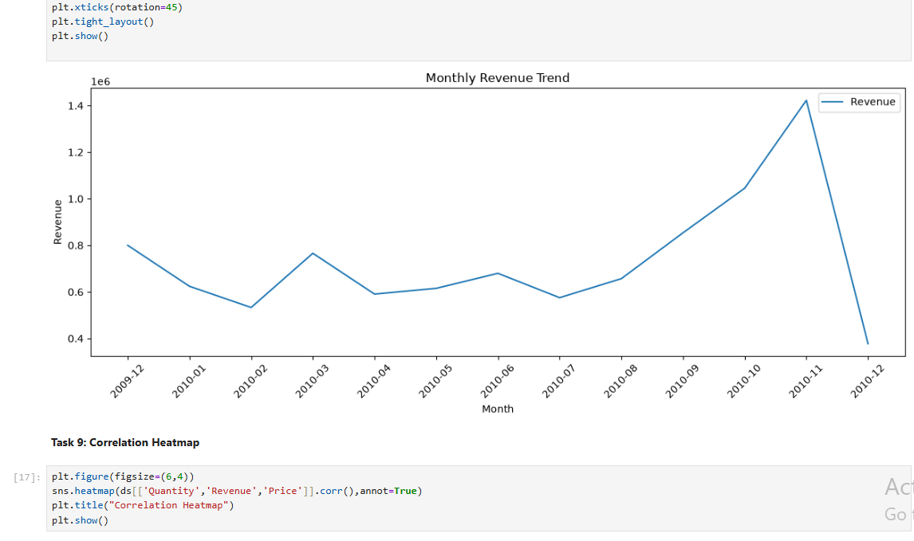
Line Graph
According to the graph, the monthly trend fluctuated throughout the year. It keeps on increasing and decreasing during initial months but spiked towards the end of the year reaching its highest point in November 2010. Then there was a sharp decline in December 2010 which is likely due to missing or incomplete data present for the entire month.
Task 9: Correlation Heat map
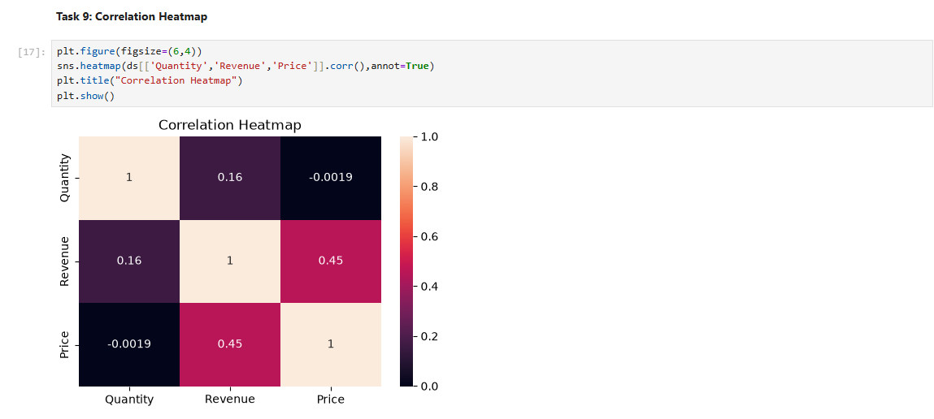
Correlation heat map was used to examine the relation between Quantity, Price and Revenue. It was created using Seaborn in order to clearly visualize the correlation coefficients between these variables.
Correlation value of 1 indicates a strong correlation between 2 variables. While a value closer to 0 indicated weak to moderate correlation.

From the map we can observe:
- Strong correlation exists when values are compared with themselves.
- Moderate positive correlation (0.45) is present between Revenue and Price indicating that higher priced product contributes to higher revenue.
- Weak positive correlation (0.16) exist between Quantity and Revenue indicating selling more products do not significantly affect the revenue.
- A weak or almost zero negative correlation (-0.0019) exists between Quantity and Price indicating that number of item purchased is not related to the price of the product.
Task 10: Outlier Detection Using Boxplot
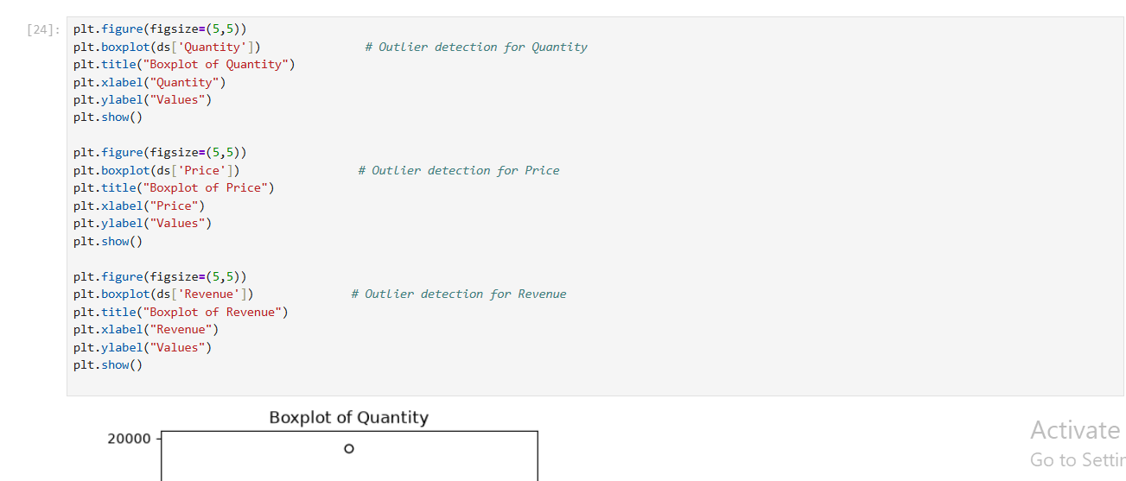
Using boxplot outlier were detected which are the extreme values present in the data that may influence the results of data analysis.
Boxplot for Quantity:
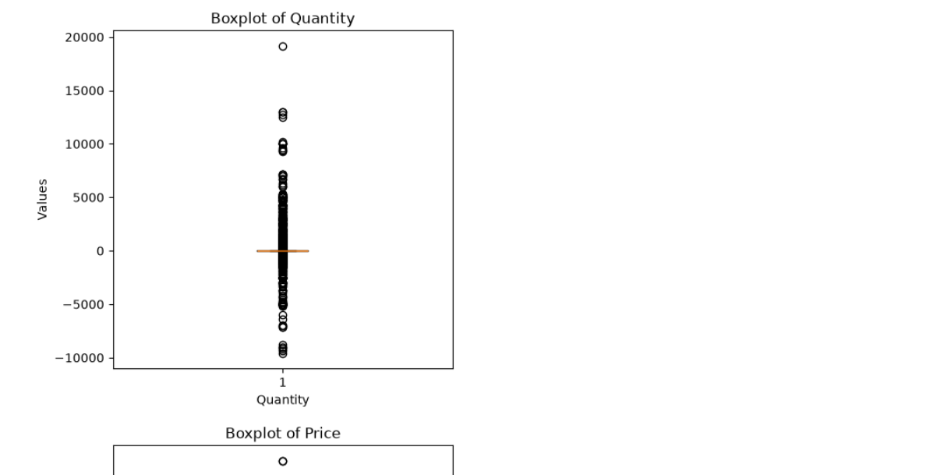
It shows several outliers above and below the normal range. The high positive values indicates bulk order while high negative values indicates returned or cancelled orders. While most of the transactions involve small quantities.
Boxplot for Price:
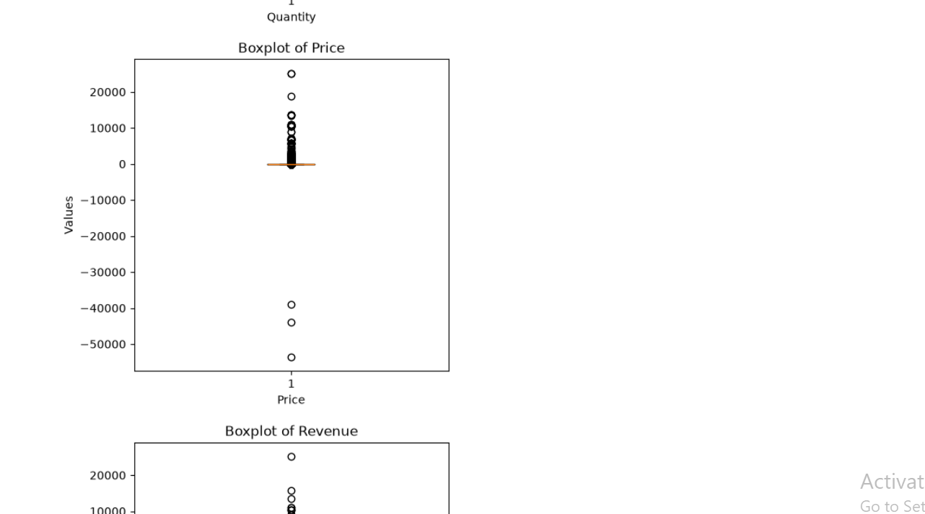
It contain outliers, most of the products are sold at lower prices while few products have high or negative prices making them outliers.
Boxplot for Revenue:
Higher positive values represents large value transactions, while negative values represent either returned or cancelled orders which resulted in negative revenue.
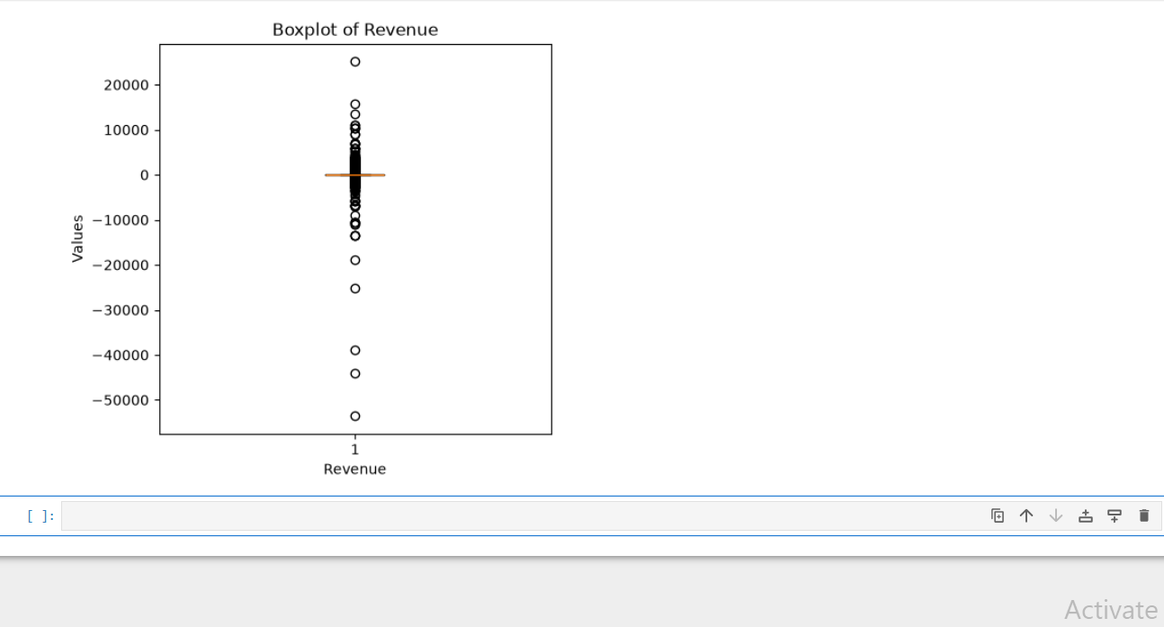
Business Insights:
- United Kingdom is the company’s primary market as highest revenue was generated there as compared to other countries.
- Monthly revenue fluctuated throughout the observed period which indicates that customer purchasing behaviors changes frequently.
- Few products contributes more to the revenue and the total sales which indicates these products are in high demand.
- Higher priced products contribute more to the revenue than the quantity sold.
- Quantity boxplot indicates bulk purchases and Revenue boxplot indicates high-value transactions.
Conclusion
This first week of the AI/ML Internship focused on developing a strong foundation in data analysis and business understanding through Exploratory Data Analysis (EDA) of the Online Retail II dataset. By successfully examining the dataset, identifying data quality issues, analyzing customer purchasing behavior, evaluating sales performance across products and countries, and visualizing key trends, I gained practical experience in transforming raw data into meaningful business insights.
The task strengthened my understanding of essential data analysis techniques, including data inspection, handling missing values and duplicate records, revenue analysis, correlation analysis, trend visualization, and outlier detection using Python libraries such as Pandas, NumPy, Matplotlib, and Seaborn.
Overall, this week's experience enhanced both my analytical and technical skills while providing a solid foundation for more advanced data preprocessing, machine learning, and predictive analytics tasks in the upcoming weeks of the internship.

